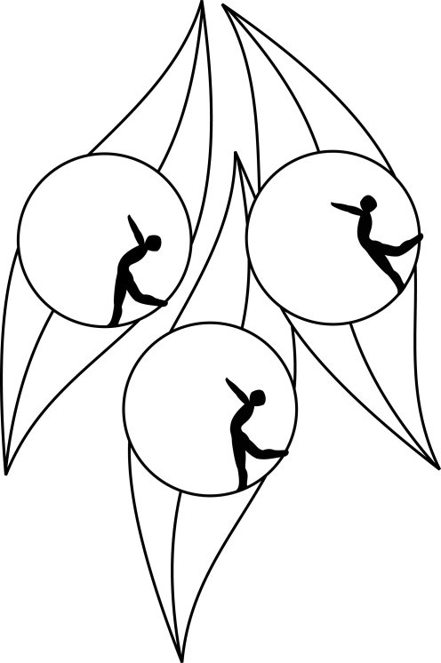
Results
South Australian Ice Skating Association Inc
Test Session

5 July 2010
IceArena, Thebarton

Congratulations to the following skaters:

Elementary 2 Figure Pattern
Alessandra Triulcio

Elementary 2 Technical
Giuseppe Triulcio

